DATA STRUCTURES AND ALGORITHMS LAB ASSIGNMENT – 4
Student Details
- Name: Pratyush Deo Singh
- Registration Number: 25BCE5101
- Course / Branch: B Tech CSE
- Semester: 2nd
- Subject: Data Structures and Algorithms
- Faculty Name: Dr. Malini A

Program 1: Infix to Postfix Conversion using Stack
Aim
To write a C program to convert an infix expression into postfix expression using stack.

Program Code
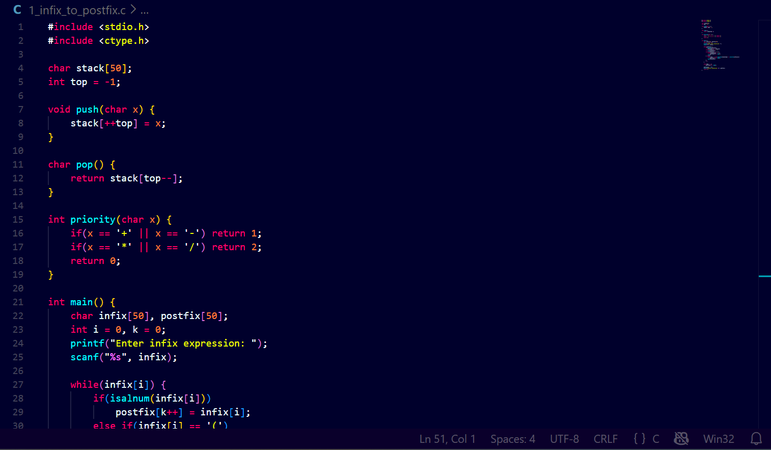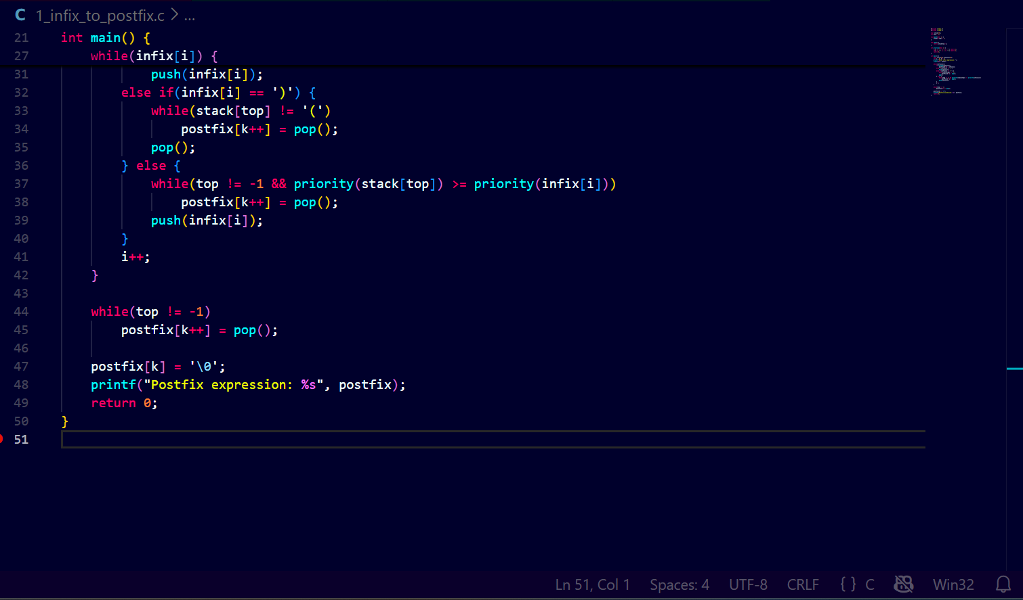
Output
Program 2: Infix to Prefix Conversion using Stack
Aim
To write a C program to convert an infix expression into prefix expression using stack.
Program Code
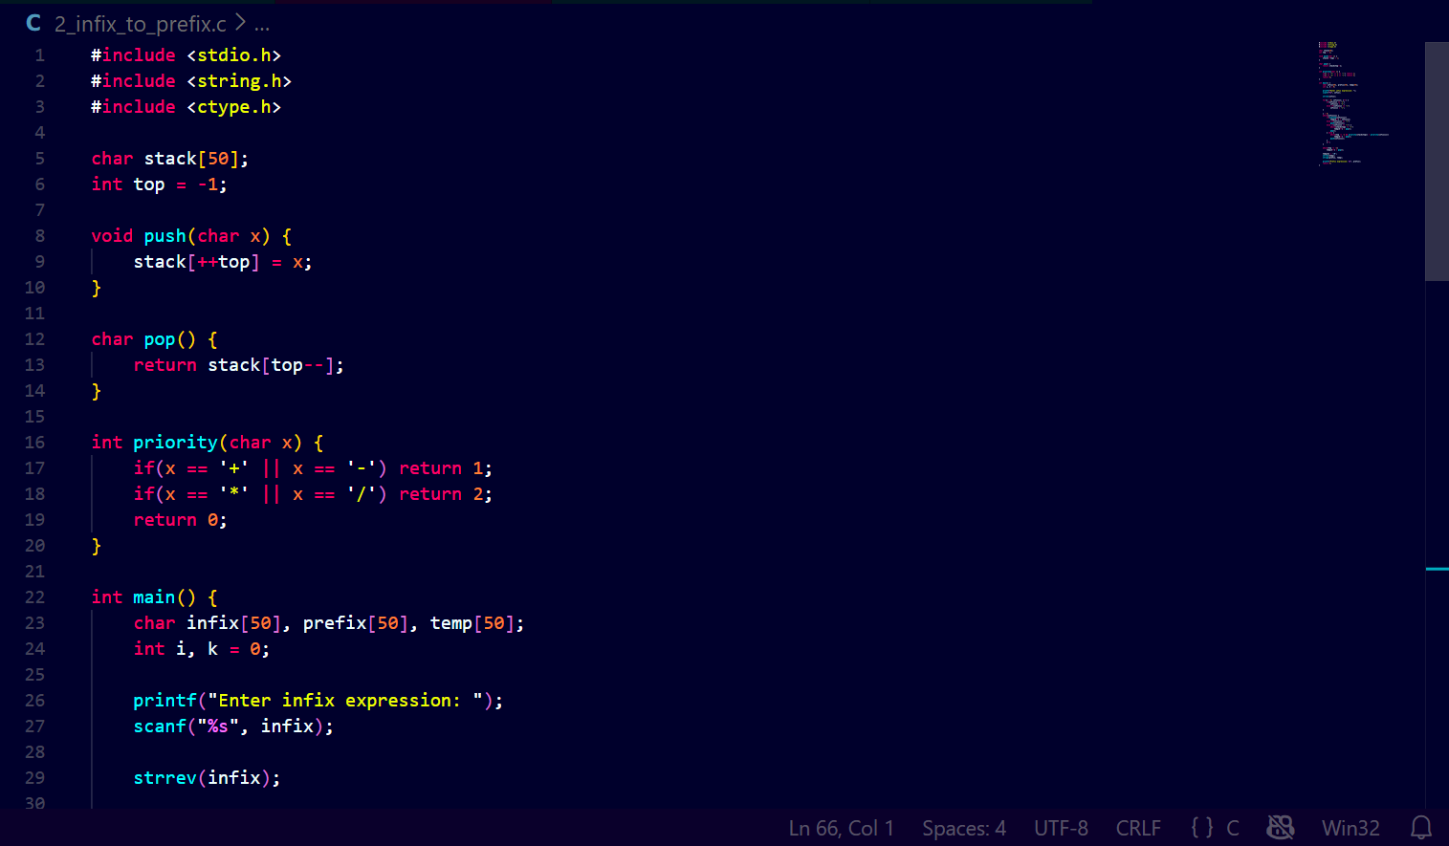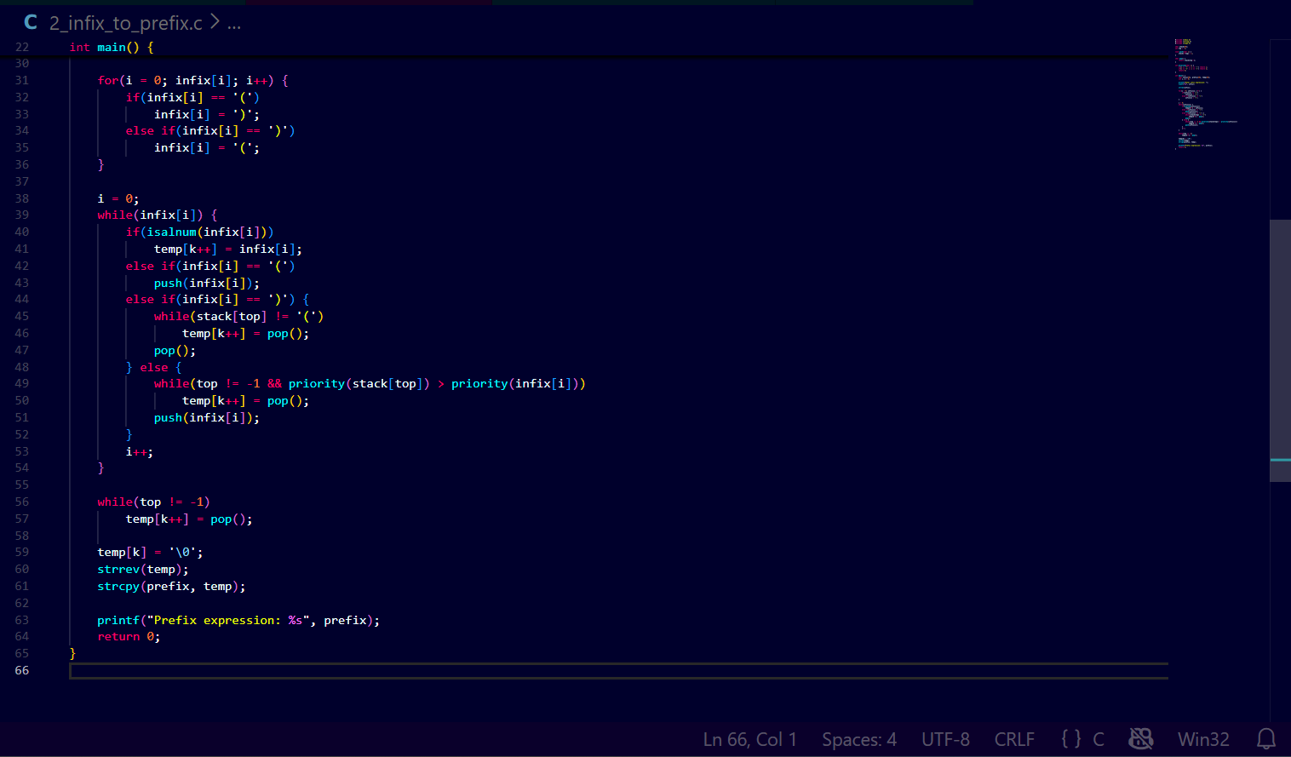Output

Program 3: Postfix Expression Evaluation
Aim
To write a C program to evaluate a postfix expression using stack.
Program Code
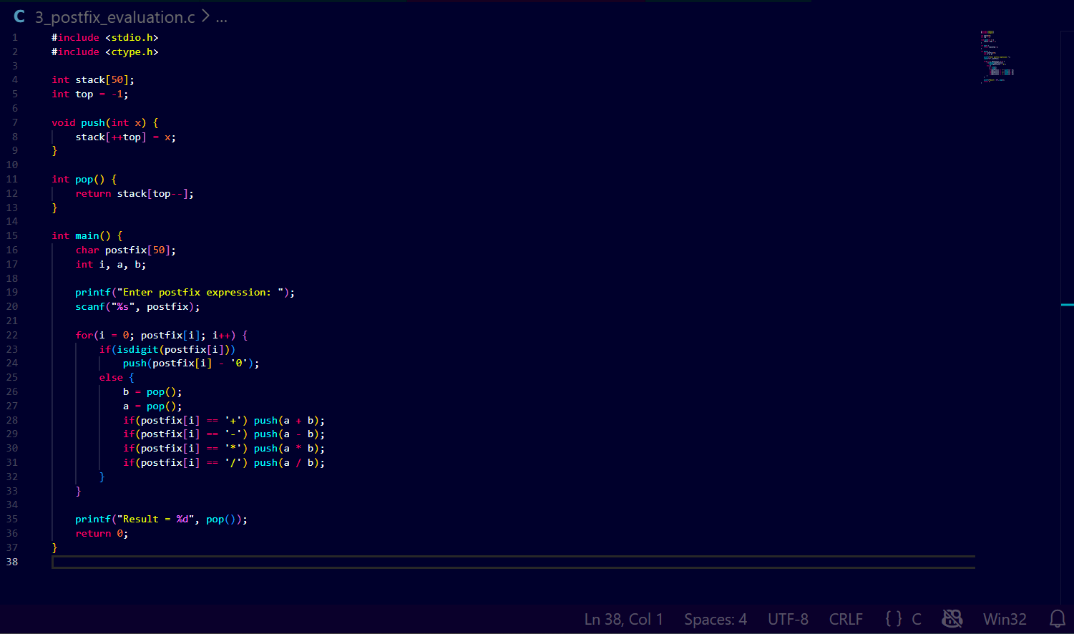Output

Program 4: Prefix Expression Evaluation
Aim
To write a C program to evaluate a prefix expression using stack.
Program Code
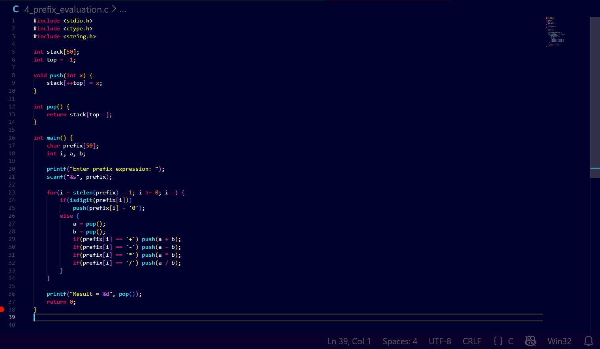Output
Result
All stack-based expression conversion and evaluation programs were successfully implemented and executed.

